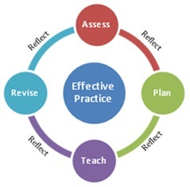
Synthesis of Student Data: Class Profile

Purpose: Creating the Class Profile supports Resident Educators’ understanding of the varied learning needs of each student.
Outcome
Through the assessment stage of the Teaching-Learning Cycle, Resident Educators and mentors develop an understanding of student learning needs at the district, school and class levels, and begin to understand the relationship between instruction and student learning outcomes.

Throughout the year, Resident Educators and mentors continually revisit district, school and class data to help inform current and future instructional planning, delivery and assessment to make the analysis of student learning a regular practice for Resident Educators.
Examination of various kinds of data should become for Resident Educators a natural part of their Teaching-Learning cycle, leading them toward planning of increasingly more effective learning experiences for their students.

Directions:
- Together, mentors and resident educators complete the Class Profile below. List each student’s name and select three data points at the class level to create a data snapshot of the entire class. Some examples of class data include literacy levels, attendance data, authentic assessment results, and discipline data.
- Once the Class Profile has been created, mentors and resident educators review it to benchmark student learning levels and to determine instructional grouping.

CLASS PROFILE
Resident Educator: |  | Date Completed:
Grade Level/Subject Area:
Student Name or ID | Data Source: |  | Date Source: | Data Source:
1.
2.
3.
4.
5.
6.
7.
8.
9.
10.
11.
12.
13.
14.
15.
16.
17.
18.
19.
20.
21.
22.
23.
24.
25.
26.
27.
28.
29.
30.
*add more rows as needed

